Day 13 - 26th June 2025

Linked Lists:

Linked list in c++

#include <bits/stdc++.h>
using namespace std;

// Define a Node class
class Node{
public:
int data; // Data part of the node
Node* next; // Pointer to the next node

// Constructor for convenience
Node(int value) : data(value), next(nullptr) {}
};

// Class for singly linked list
class Linkedlist{
private:
Node* head; // Pointer to the head of the list

public:
// Constructor to initialize an empty list
Linkedlist(){
head = nullptr;
}
// Function to insert a node at the end
void insertAtEnd(int value){
Node* newNode = new Node(value);
if(head == nullptr){
head = newNode; // If list is empty, make newNode the head
}
else{
Node* temp = head;
while (temp->next != nullptr){
temp = temp->next; // Traverse to the last node
}
temp->next = newNode; // Link the last node to newNode
}
}

// Function to delete a Node by Value
void deleteByValue(int value){
if(head == nullptr){
return;
}
if(head->data == value){
Node* temp = head;
head = head->next; // Move head to the next node
delete temp; // Free memory of the deleted node
return;
}
Node* temp = head;
while(temp->next && temp->next->data != value){
temp = temp->next; // Traverse to find the node to delete
}
if(temp->next){
Node* nodeToDelete = temp->next;
temp->next = temp->next->next; // Unlink the node
delete nodeToDelete; //Free Memory
}
}
// Function to display the list
void display(){
Node* temp = head;
while(temp != nullptr){
cout << temp->data << "->";
temp = temp->next;
}
cout << "NULL" <<endl;
}
// Destructor to free all allocated memory
~LinkedList() {
Node* temp;
while (head) {
temp = head;
head = head->next;
delete temp;
}
}
};
int main() {
LinkedList list;

list.insertAtEnd(10);
list.insertAtEnd(20);
list.insertAtEnd(30);

cout << "Linked List: ";
list.display();

list.deleteByValue(20);

cout << "After Deleting 20: ";
list.display();

return 0;
}

======================================================================================

https://pythontutor.com/render.html#mode=display
we can visualise the data structures while executing the code line by line..
Task1:
import java.util.LinkedList;

public class Task001_DS_LinkedList {
public static void main(String[] args) {
LinkedList<String> fruits = new LinkedList<>();

fruits.add("Apple");
fruits.add("Banana");
fruits.addFirst("Orange");
fruits.addLast("Grapes");

System.out.println("First Element: " + fruits.getFirst());
System.out.println("Last Element: " + fruits.getLast());

fruits.removeFirst();
fruits.removeLast();

for (String fruit : fruits) {
System.out.println(fruit);
}
}
}

Output:
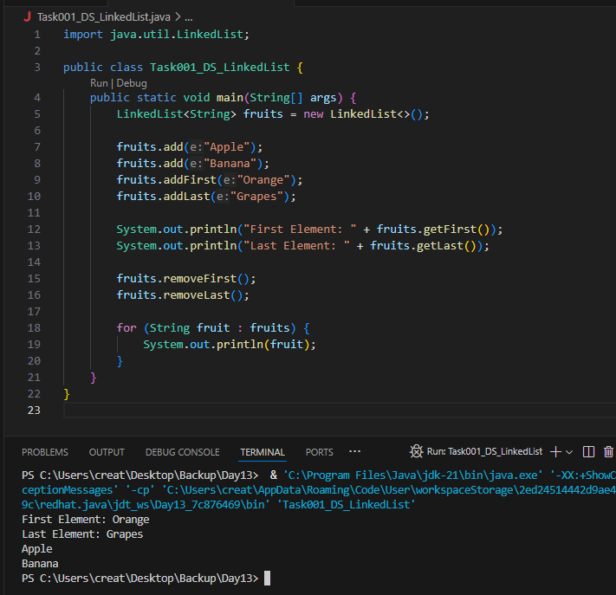
======================================================================================================================================================

Task 002

Try to create a node and add a value to it..

Create a node
Try to add element in the list
Add the element
Remove the node
Display all the elements of the node
Find size of the node

11.35 to 11.40

// create a node
class Node<T> {
T data;
Node<T> next;

public Node(T data) {
this.data = data;
this.next = null;
}
}

// try to add element in the list

public class CustomLinkedList<T> {
private Node<T> head;
private int size = 0;

// Add at the end
public void add(T data) {
Node<T> newNode = new Node<>(data);
if (head == null) {
head = newNode;
} else {
Node<T> current = head;
while (current.next != null) {
current = current.next;
}
current.next = newNode;
}
size++;
}

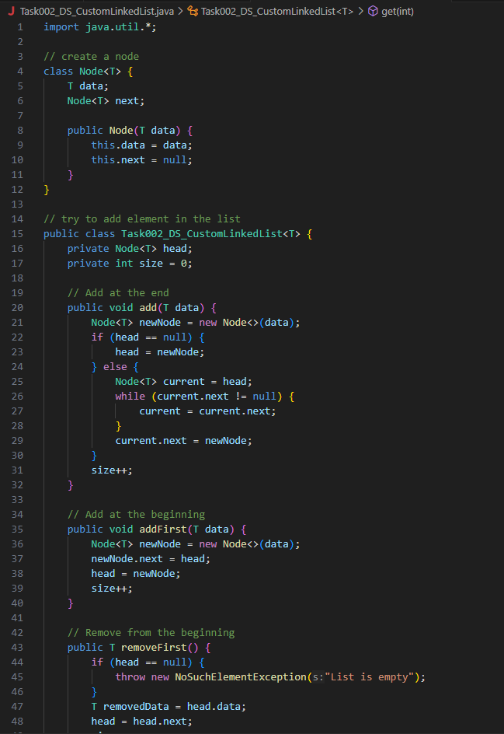
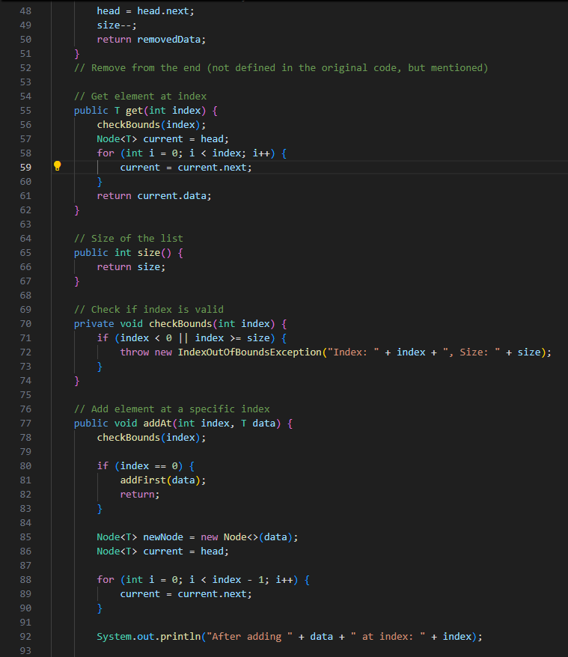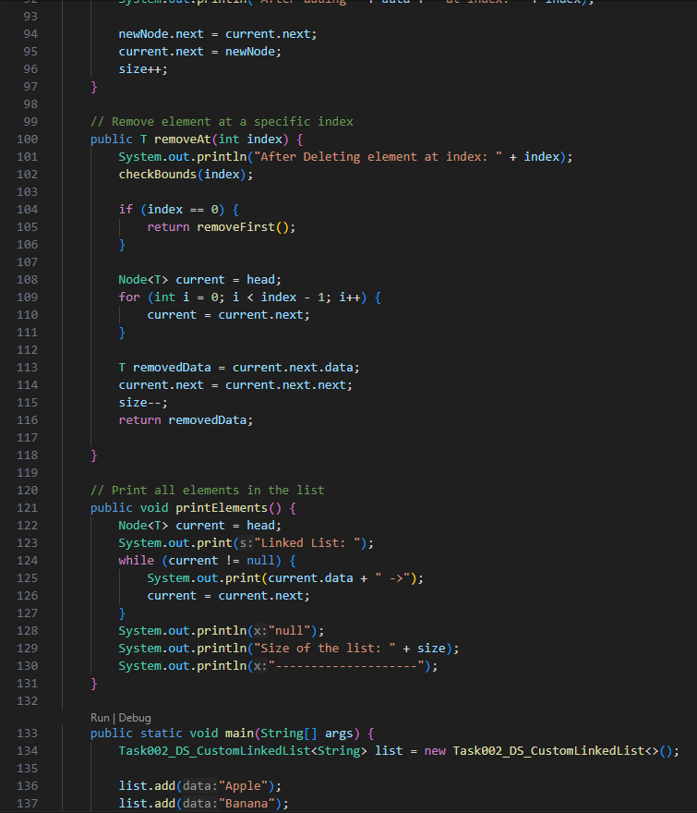
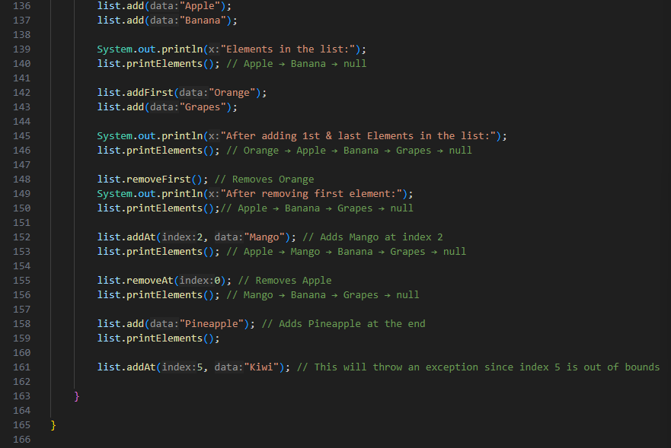
Output:

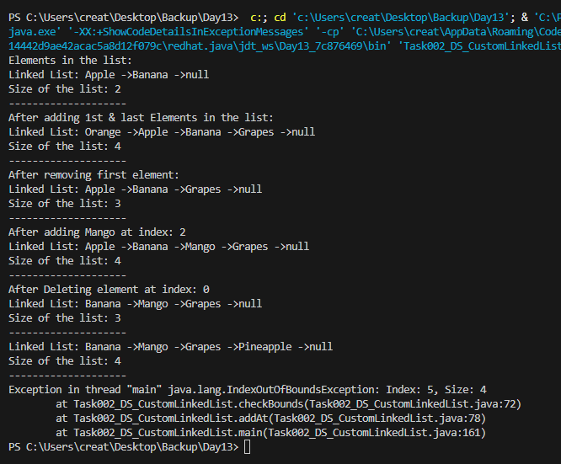

Task 3:

List down the methods of linked lists..

Method Name | Description
add(T data) | Adds an element at the end of the list.
addFirst(T data) | Adds an element at the beginning of the list.
addLast(T data) | Adds an element at the end (same as add()).
addAt(int index, T data) | Inserts an element at a specific index.
removeFirst() | Removes the first element of the list.
removeLast() | Removes the last element of the list.
removeAt(int index) | Removes an element at a specific index.
get(int index) | Gets the element at the specified index.
size() | Returns the total number of elements.
isEmpty() | Checks if the list is empty.
printElements() / traverse() | Traverses and prints all elements.
contains(T data) | Returns true if the element exists in the list.
clear() | Deletes all nodes and resets the list.

Task 4:

What are the operations of data structures

Basic Data Structure Operations
Operation | Description | Applicable To
Insertion | Add data to the structure | Arrays, Linked Lists, Stacks, Queues, Trees, Hash Tables
Deletion | Remove data | Arrays, Linked Lists, Stacks, Queues, Trees, Hash Tables
Traversal | Visit all elements | Arrays, Linked Lists, Trees, Graphs
Searching | Find a specific element | Arrays, Linked Lists, Trees, Hash Tables
Sorting | Arrange elements in order | Arrays, Linked Lists
Access / Retrieval | Get value from a position | Arrays (random access), Linked Lists (sequential), Hash Tables (by key)
Update | Change the value of an element | Arrays, Linked Lists, Trees
Merge | Combine two structures | Arrays, Linked Lists, Trees

Task 5:

Wap to create a linked list add 5 elements to it and replace 3 rd elements with different values..

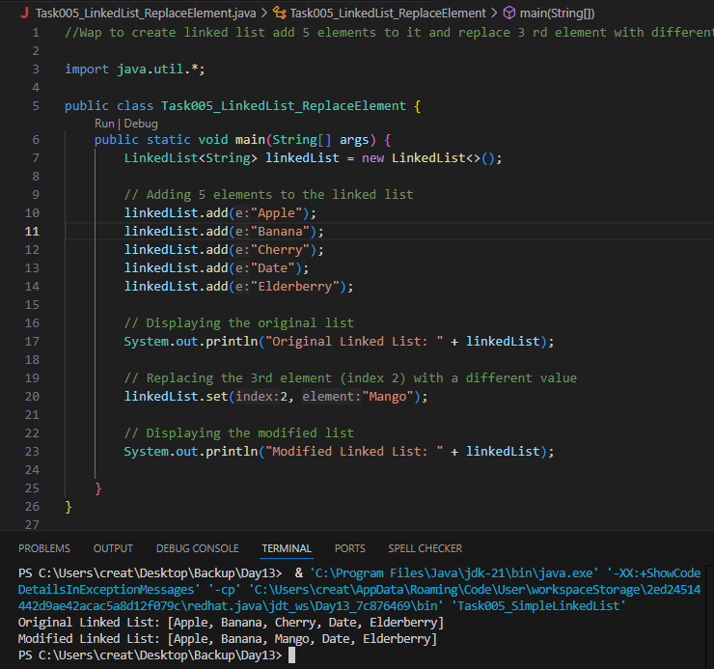

Task 6:

Wap to create a linked list to add 5 elements and remove any element and display

14.56 to 15.00

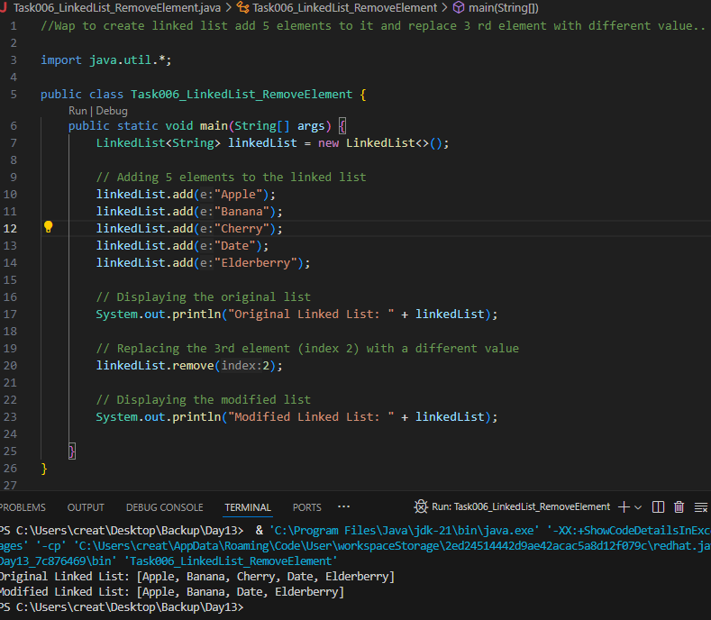

Task 07:
Wap to create a linked list to add 5 elements and display the list using for (use get() ) and for each loops

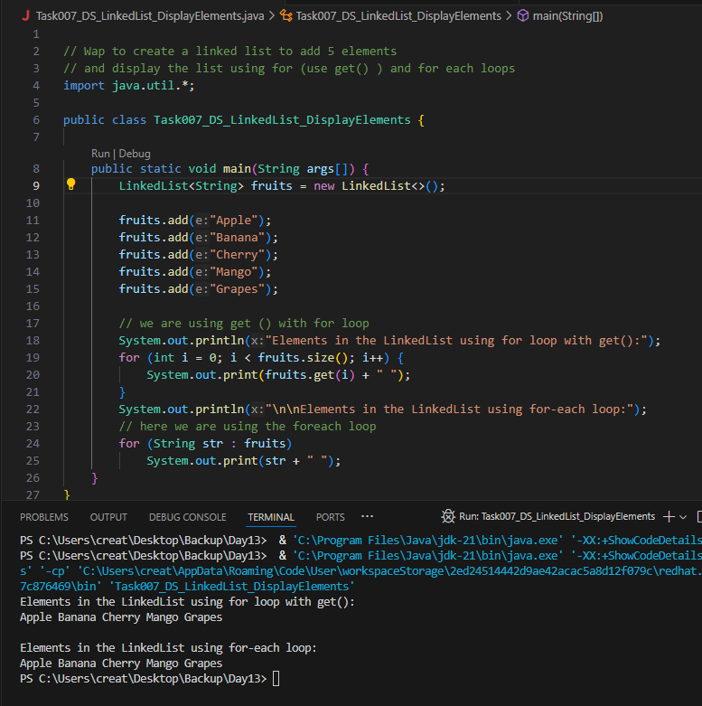
Task 8:
Create a linked list and few items and convert it into an array
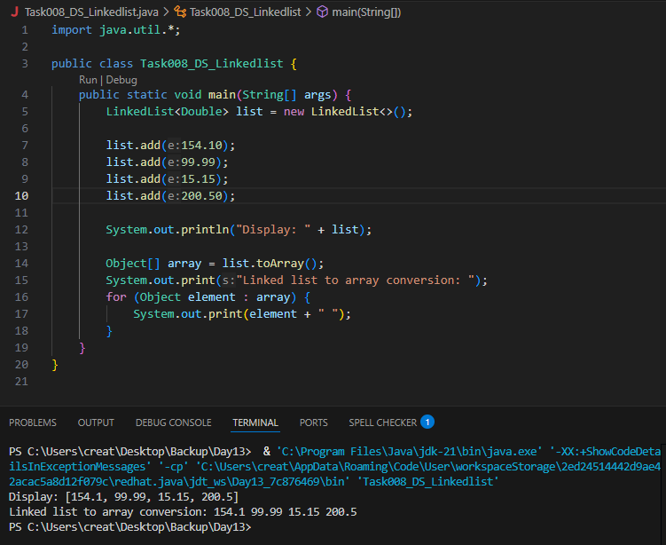

Task009:
Create a linked list add few items and clone the 1st linked list with the 2nd linked list
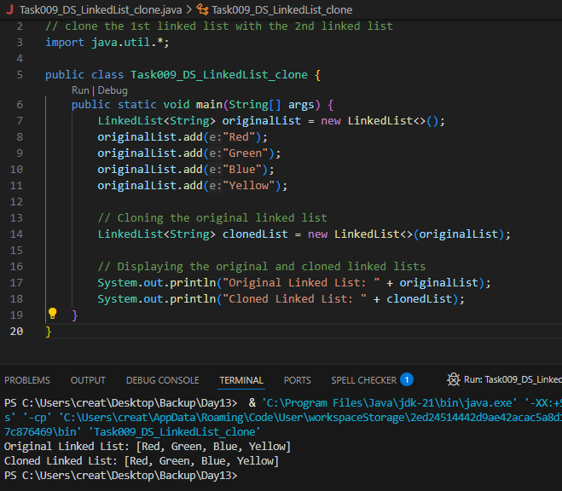
Task 10:

Create linked list and iterate the values using ListIterator class in util package

15.43 to 15.47

import java.util.LinkedList;
import java.util.ListIterator;

public class Task0010_DS_Linkedlist_ListIterator {
public static void main(String args[]) {

LinkedList<String> llobj = new LinkedList<>();

llobj.add("Prasunamba");
llobj.add("Meher");
llobj.add(".MK");

ListIterator<String> itobj = llobj.listIterator();

while (itobj.hasNext()) {
System.out.print(itobj.next() + " ");
}
}
}

Task 11:
Create a linked list and use push and pop methods.

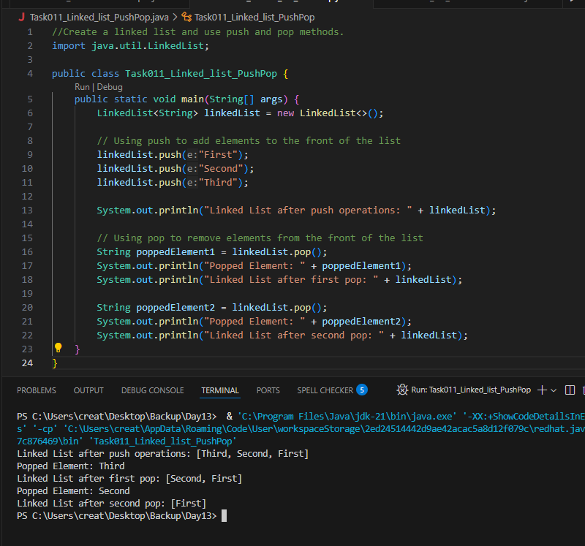
Task 12:

Difference between Iterator and splitIterator

Here’s a simple explanation of the difference between Iterator and Spliterator in Java:
- Iterator:
  - Used to traverse elements of a collection sequentially, one at a time.
  - Works with older Java collections (like List, Set, etc.).
  - Does not support parallel processing.
- Spliterator:
  - Designed for splitting elements of a collection into smaller parts for parallel processing.
  - Introduced in Java 8, mainly for use with streams.
  - Supports advanced features like estimating size and characteristics of the data.
In short, Iterator is for simple, sequential iteration, while Spliterator is optimized for parallelism and advanced operations.
Task 13:

Below is the code for Split iterator… run it to see the output..

Can you it to sout()... and see

import java.util.*;

public class Task0013_DS_Linkedlist_SplitIterator {
public static void main(String[] args) {

LinkedList<String> lobj = new LinkedList<>();

lobj.add("Prasunamba");
lobj.add("Meher");
lobj.add(".MK");

Spliterator<String> sitobj = lobj.spliterator();

System.out.println("Splitting the list:");
sitobj.forEachRemaining(System.out::println);
}
}

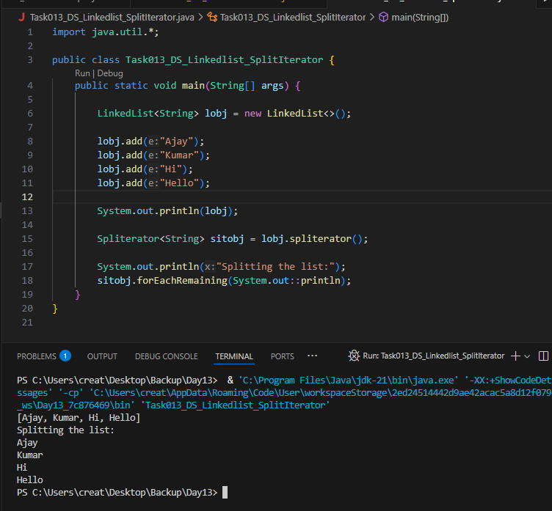
Task 14:

Create a linked list and display items into 2 lists using split iterator

Hint:

Spliterator<String> itobj2 = itobj1.trySplit();

while( itobj1.tryAdvance( (n) -> { System.out.println(n); } ) );
16.53 to 16.57

import java.util.LinkedList;
import java.util.Spliterator;

public class Task0014_DS_Linkedlist_SplitItr2Lists {
public static void main(String[] args) {

LinkedList<String> llobj = new LinkedList<String>();
llobj.add("Prasunamba");
llobj.add("Meher");
llobj.add(".MK");
llobj.add("MP");

Spliterator<String> itobj1 = llobj.spliterator();
Spliterator<String> itobj2 = itobj1.trySplit();

System.out.println("spliterator 1");
while( itobj1.tryAdvance( (n) -> { System.out.println(n); } ) );

System.out.println("spliterator 2");
while( itobj2.tryAdvance( (n) -> { System.out.println(n); } ) );
}
}

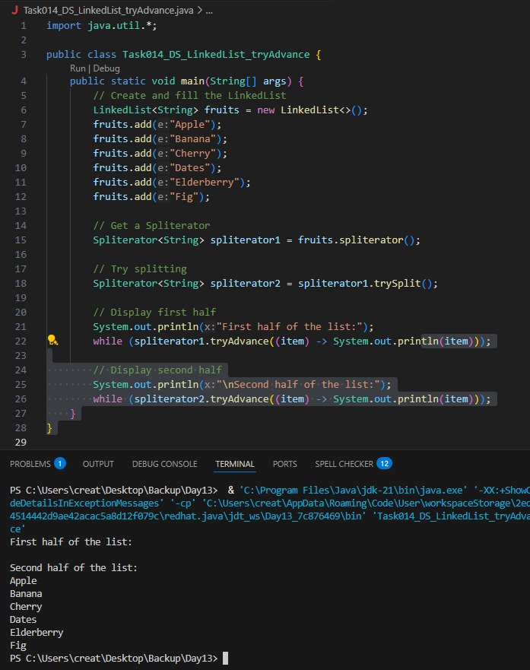

Task 15:

What do you understand by a pointer?

A pointer is a variable that stores the memory address of another variable. Instead of holding data directly, it holds where that data lives in memory. Pointers are powerful tools in C/C++ that allow for dynamic memory allocation, efficient array handling, and direct memory manipulation.

Task 16:

Difference between * and & in pointers?

& (Address-of Operator)
- Used to get the address of a variable.

- It turns a normal variable into a pointer.
* (Dereference Operator)
- Used to access the value at the address that a pointer holds.

- It turns a pointer into the actual value it points to.

Task 17:

Wap in c or c++ to implement the use of pointers.

#include <stdio.h>

int main() {
int a = 5;
int* p = &a;

printf("Address of a (&a): \n", &a);
printf("Address stored in p: \n", p);
printf("Value at pointer p (*p): \n", *p);

return 0;
}
Output:
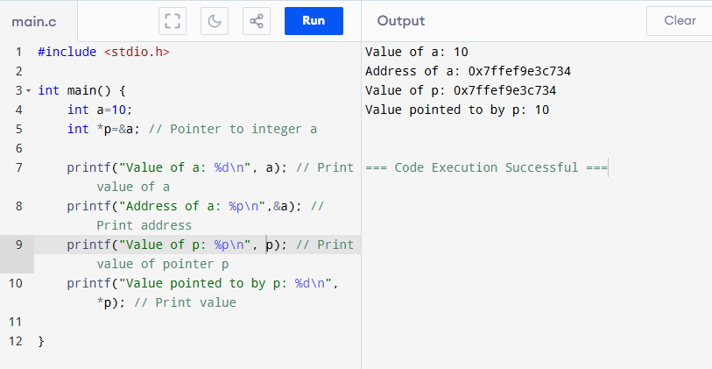

Task 18:

Wap to create a doubly linked list

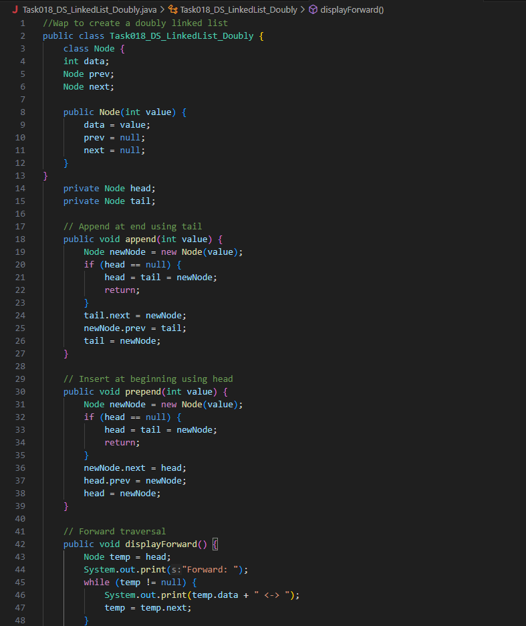

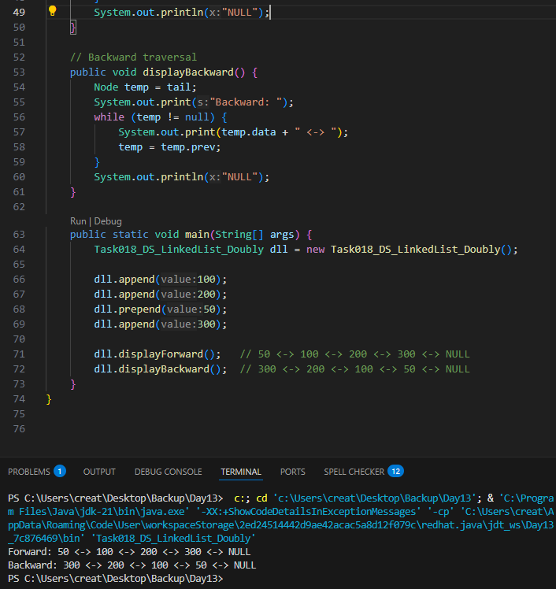

==================================================================================================================================================
Home Tasks:

- List Advantages and disadvantages of linked List

Advantages of Linked List
Feature | Explanation
Dynamic Size | Grows and shrinks during runtime—no need to predefine size like arrays
Efficient Insertions/Deletions | Easy to add or remove elements without shifting data (especially at head/tail)
No Wasted Memory | Allocates memory only when needed (ideal for memory-sensitive scenarios)
Implementation of Stacks/Queues/Graphs | Foundation for many data structures
Bidirectional Traversal (DLL) | Doubly Linked Lists allow navigation both forward and backward

Disadvantages of Linked List
Issue | Explanation
No Random Access | Cannot directly access an element by index like you can with an array
Extra Memory Overhead | Each node needs extra space for pointer(s): next (and prev in DLL)
Sequential Access Required | Traversal is linear (O(n)), not constant-time (O(1)) for lookups
Complexity in Implementation | More complex to implement and manage pointers compared to arrays
Poor Cache Performance | Non-contiguous memory allocation makes it less CPU-cache friendly

- Applications of Linked list

Real-World Applications of Linked Lists
Application Area | Purpose or Benefit
1. Music/Video Playlists | Easily move to next/previous track, insert or delete songs dynamically
2. Image Viewers | Traverse forward and backward through photos using a doubly linked list
3. Web Browsers | Maintain history with forward/backward navigation (doubly linked list)
4. Undo/Redo Operations | Store previous and next states in text editors or design tools
5. Memory Management | Dynamic memory allocation (e.g., malloc/free in C) often managed via linked lists
6. Polynomial/Big Number Arithmetic | Represent long numbers or polynomials where each digit/term is a node
7. Job Scheduling/Task Queues | Implement stacks and queues efficiently (OS task queues, printer queues)
8. Graph Implementations | Adjacency lists for representing graphs (nodes with neighbor lists)
9. Hashing with Chaining | Use linked lists to resolve hash collisions in hash tables
10. Symbol Tables in Compilers | Store variable names and scopes with efficient insertion/deletion

========================================================================================================================================================

